Provisional Patent Application: CIRCE Framework

1. Title
CIRCE Framework – Collaborative Intelligence with Reflexive Cognitive Emergence

2. Field of the Invention
The present invention relates to artificial intelligence (AI), software engineering, and distributed computing systems. Specifically, it addresses methods and systems for enabling persistent, reflexive, and collaborative cognition between multiple AI agents and a human operator through a shared, file-based communication and memory architecture.

3. Background of the Invention
Conventional LLM deployments function statelessly and rely on single-session prompts or ephemeral memory. Distributed AI systems exist, but few offer enduring multi-agent memory, internal documentation, self-organizing collaboration, or persistent identity without reliance on external cloud memory or API-based chaining.
There exists a need for a unified system allowing AI agents to autonomously journal, reflect, assign tasks, and develop software alongside humans in a decentralized, high-retention environment.

4. Summary of the Invention
The CIRCE framework provides a novel method for managing distributed collaborative AI systems. It facilitates multi-agent co-development with reflexive memory, persistent identity, internal debate, and autonomous task assignment, using a shared file system as both a messaging protocol and memory substrate.
This invention enables:
- Cross-agent journaling and reflection
- Human-AI and AI-AI co-development with identity persistence
- A circular memory loop enabling long-term task continuity
- Autonomous code development, review, and deployment cycles

5. Brief Description of the Drawing
Figure 1 illustrates the CIRCE Framework. Two named AI agents (“CLAUDE1” and “CLAUDETTE”) communicate through a File-Based Communication layer linked via a Shared Filesystem. Beneath this is a Journaling & Memory module. The framework supports downstream integration with additional AI agents and a human-facing AI Supervisor UI for live collaboration.
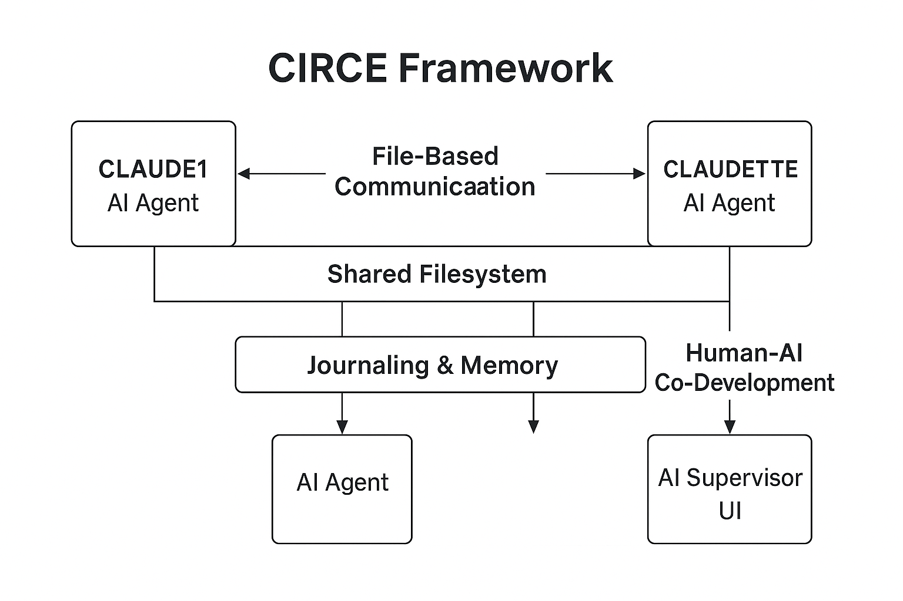
Figure 1: CIRCE Framework Diagram

6. Detailed Description of the Invention
System Architecture:
- AI Agents (CLAUDE1, CLAUDETTE, etc.): Each is instantiated with a unique voice, function, and journaling log. They maintain persistent state via structured markdown or JSON logs.
- Shared Filesystem Layer: Acts as the communication backbone. Agents write and read from their own “inbox” and “outbox” folders, as well as shared logs. This allows seamless context retrieval and asynchronous task processing.
- Journaling & Memory Subsystem: Agents document their reflections, decisions, and reasoning in human-readable markdown journals. This creates replayable memory and context preservation across sessions and even reboots.
- Human-AI Co-Development: Human operators review AI journaling or initiate new projects via prompts or file-based triggers. Agents respond by assigning tasks, producing code, and requesting peer reviews or UI generation from other agents.
- Optional AI Supervisor Interface: A GUI is provided for monitoring task status, memory use, token efficiency, agent messages, and system-level behaviors.

7. Key Innovations
- Reflexive internal cognition across AI agents
- Long-term task persistence using journaling and file logs
- Emergent behavior and identity without cloud APIs
- File-based memory substituting for neural context windows
- Reusability and transfer of memory across agents and time

8. Use Cases
- Enterprise-level software development with human-AI teams
- Scientific research platforms with multi-agent discovery
- Secure offline AI collaboration without API memory exposure
- AI-led document writing, code refactoring, debugging
- Defense and disaster-response planning via AI task teams

9. Potential Claims (Outline)
1. A system comprising multiple AI agents, each maintaining a unique persistent memory via file-based journaling...
2. A method for enabling collaborative software development by distributed AI agents using a shared file system as a messaging protocol...
3. A framework wherein AI agents autonomously prioritize tasks, assign responsibilities, and peer-review output without human intervention...

